**DATA VISUALIZATION USING MICROSOFT POWER -BI**

PROJECT CREATED ON BASIS OF

**HOW CORONA VIRUS  AFFECTS INDIAN  WOMEN IN 2020**

IBM Program – IT, Networking and Cloud (Technical Diploma) 2019-2020

**Submitted By   :  NIHARIKA SINGH**

**Roll No     :      ADIT19AU00537**

**NSTI (W) CP-16,CP BLOCK,SECTOR-V,SALTLAKE CITY, KOLKATA**

**Mr. Abhishek Raman                   Mr. K.L. Kuli                                Mr. Sarbojit Neogi**

**IBM Faculty                                 To/ADIT Director                              AD/Section In-charge**



* We have taken efforts in this project. However,it would not have been possible without the kind support and help of many individuals and organizations. We would like to extend our sincere thanks to all of them.

* We are highly indebted to the teacher in charge “MR. ABHISHEK RAMAN”( Edunet Foundation)For his able guidance and constant supervision as well as providing necessary information regarding the project & also for his support in completing the project.

* We would also like to extend our gratitude to our principal sir of NSTI (W)Saltlake kolkata “SRI G.C RAMAMURTHY “ & trade in charge of adv. Diploma in cloud computing and networking “MR. SARBOJIT NEOGI “ for providing golden opportunity of this project.

* We are really thankful to our peer group and our team members ,who helped us a lot in finalizing the project within the limited time frame

**CONTENT OF THE PROJECT:**

* How to visualize data using Power BI?I ➢ Introduction –What is Data Visualization?
* Technology used.
* What is Power BI?
* Get Power BI-DESKTOP.
* Supported operating system.
* Power BI key features.
* Top 3 component of Power BI.
* Revolutionizing BI landscape.
* Working of Power BI Architecture.
* Benefits of Power BI .
* Report created with the description.
* Important KPIs on which report s are made.
* Visual representation of the KPIs are given.
* Customized Dash board
* Aims and Objectives of the project.
* Concluision.

**How to visualize data using Power BI?**



**Introduction:**

**What is Data Visualization?**

With the technological revolution, data went from expensive, difficult to find and collect to abundant, cheap, but incomprehensible. It is arduous to store, understand and analyze increasingly larger volumes of data with traditional software’s. However, as individuals or an organization, all of this data is only as good as what we can make out of it. This is where Big data comes into play. Big data is used for predictive analytics, analyzing user behavior or other data analytics processes to bring value to data. Yet, the raw details about this can remain uncertain due to lack of knowledge. Data Visualization helps tackle this issue. Data Visualization is the process of transforming data into charts, images, graphs and even videos that explain the numbers and allow us to gain insights from it.

**Technology used**: Power BI Desktop version is used on windows 10 platform to create real time reports and efficient dashboards after connecting the data form excel to Power BI. To create a web based data science model in our project we collect our necessary data from different data sources eg. kaggle, githuhb..etc

**What is Power BI?**

Microsoft Power BI is a data visualization tool that allows you to quickly connect your data, prepare it, and model it as you like. It gives you the power to transform all your data into live interactive visuals, create customized real time business view dashboards, thus extracting business intelligence for enhanced decision making. You can visualize data and share insights. This tool allows you to embed your custom visualizations into your app or website, connect to hundreds of data sources like excel, google analytics, IoT devices for real time data etc. It amalgamates everything conveniently with your existing professional environment allowing you to acquire analytics and reporting capabilities. You can publish these reports, therefore allowing all the users to avail the latest information.

**Get Power BI Desktop:**

Supported Operating Systems

* Windows 10, Windows 7, Windows 8, Windows 8.1, Windows Server 2008 R2, Windows Server 2012, Windows Server 2012 R2
* Microsoft Power BI Desktop requires Internet Explorer 9 or higher
* Microsoft Power BI Desktop is available for 32-bit (x86) and 64-bit (x64) platforms Users can select a language in which they want to install Power BI and following files are available for download.

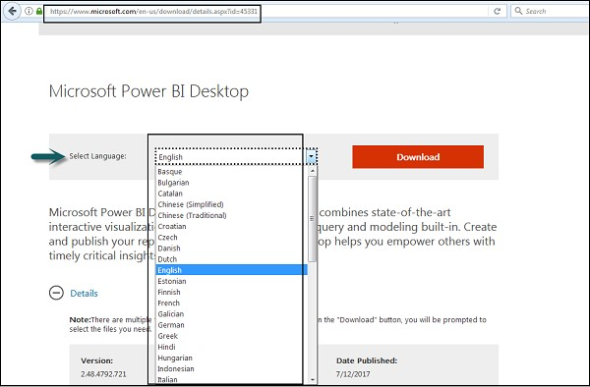

This is the link to directly download Power BI files − https://www.microsoft.com/en-us/download/details.aspx?id=45331

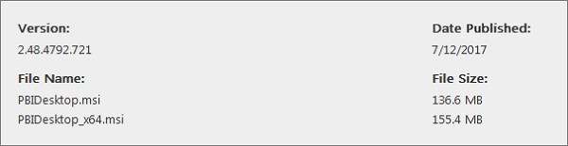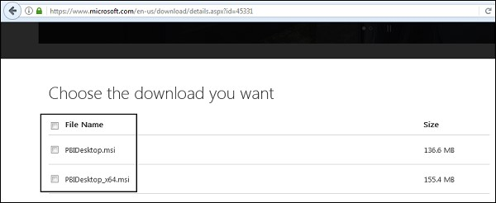

PBIDesktop_x64.msi shows a 64-bit OS file. Select the file you want to install as per OS type and click Next. Save the installation file on the local drive.

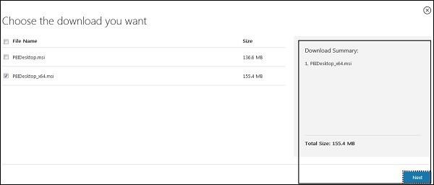

When you run the installation file, following screen is displayed.

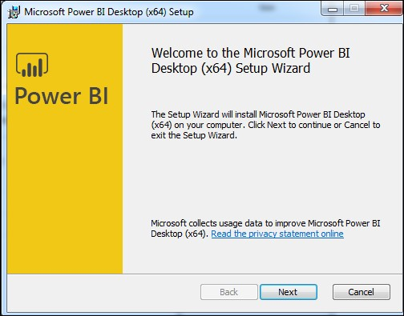

Accept the license agreement and follow the instructions on the screen to finish the installation.

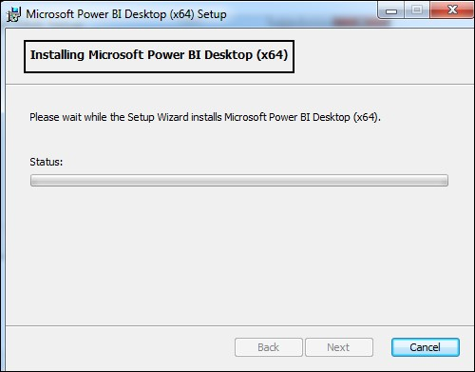

When Power BI is installed, it launches a welcome screen. This screen is used to launch different options related to get data, enrich the existing data models, create reports as well as publish and share reports.

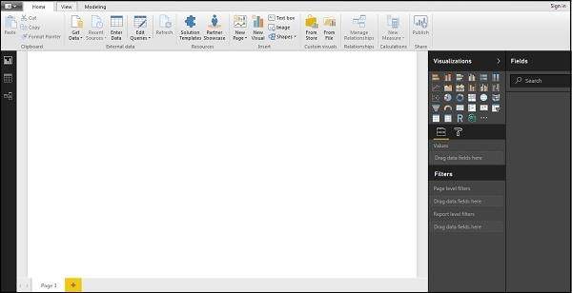

***Power BI- The Key Features :***

**1.Interactive Power BI desktop***:*

This interactive Power BI desktop tool allows you to build reports by accessing the data quickly. One doesn’t need to have advanced skills to create a report with this powerful tool, it is quick and easy to learn to use.. Also, the best thing about his tool is that it is free to download tool, allowing you to create reports without possessing any technical knowledge.

1. **Customized Visualization:**

Every organization functions differently, and they have their own way of getting things done. There are times when the right way to go is the standard way. Well, the same applies in the case of visualization*.*

The Power Bi tool has a default standard, which sometimes is not sufficient for the organizations due to complex data. Under such circumstances, organizations can easily access the custom library of visualization and design yourself a visualization that servesyour needs well.

1. **Visibility:**

The center of all businesses is data, and the main challenge that organizations face today is manipulating the data with other datasets to derive useful information.

Well, an effective way to do that is by collecting various datasets and organizing them visually for the purpose of better understanding. This form helps in delivering a deeper understanding of the data using which organizations can enjoy a competitive advantage over their competitors.

So these were a few features of Power BI. Now, let’s move forward and have a look at what empowers the Power BI to deliver actionable insights.

When it comes to Power BI, it is one tool that allows the process of data analysis to be quick, agile, and user-generated. It not only simplifies the task of data collaboration, analysis, and sharing but also makes takes the same to the next level.

Here is a list of top three components that empower the performance of the BI solution at every step of the analysis.

# Power BI- Top Three Components

1. **Power Pivot:**

This component imports and integrates different datasets from different sources to develop in-memory data models. Such integration makes it easy for any functional user to improve the overall value by combining various data sources.

The most classic examples of such integrations are when corporate sales/demographic/weather data is analyzed by using the tool Power BI.

This component also supports complex calculations, key performance, and indicators, which can further be used by data analysts for prototyping and doing analysis of different business situations.

1. **Power Query:**

This component searches for data in various corporate data sources or online, and the picked dataset is then seamlessly imported into an Excel table, which serves to be a game-changing feature for many analysts. The native data connectivity feature offered by this component enables quicker and simpler access to the data.

Power query does the tasks like renaming a column, replacing the values, merging the data, and other critical data modifications. This component is a big deal since it allows data cleansing and shaping hassle-free.

1. **Power View:**

When it comes to visualizing the data and making it even more interactive, Power View is the go-to component. It is supposed to cross-filter and highlight the data. Working with the data in the Power view component feels almost the same as working with Excel and PowerPoint tools. Apart from the graphs, tabular data, and charts, Power view supports different maps that have zoom and pan capabilities.

**Power BI- Revolutionizing Business Intelligence Landscape:**

If a business fails to deliver critical insights, it will lose the competitive edge and start to experience sales at a slower pace. And when it is about the most actionable business insight, there is nothing better than Power BI.

This tool holds the power to change big data into visualizations and reports that are easy to understand.

Now, the following are how Power BI has revolutionized the world of business intelligence.

**1.Robust Security :**

To set up access to the control panel, Power BI uses Active Directory, and it is only through this panel that the organization will use different Microsoft solutions. Well, besides creating a traditional security layer, the Power BI is designed for developing security that allows the team to grant access in a very controlled manner.

1. **Organized and Accessible Data:**

Power BI was engineered to integrate a variety of Microsoft Tech, such as SharePoint and SQL databases. Currently, it is even taking data from nonMicrosoft resources.

Power BI can easily connect and integrate big data, streaming data, onpremise data sources, excel spreadsheets, and cloud data. So, it does not matter where the data is lying down; Power BI can merge and analyze it from any source as it is known to connect hundreds of sources of data seamlessly.

1. **Easy Implementation Process:**

The process of implementing Power BI across an organization is pretty easy as it calls for very few IT resources and engineering abilities. In fact, there are a few instances when it doesn’t even require any technical knowledge on part of the end-users.

All that managers have to do is develop an [API key](https://rapidapi.com/blog/api-glossary/api-key/) and plug the same inside the software. Using Power BI is even more straightforward for an enterprise using Microsoft systems such as Office 365 since BI solutions easily integrate with Office 365 and other Microsoft systems.

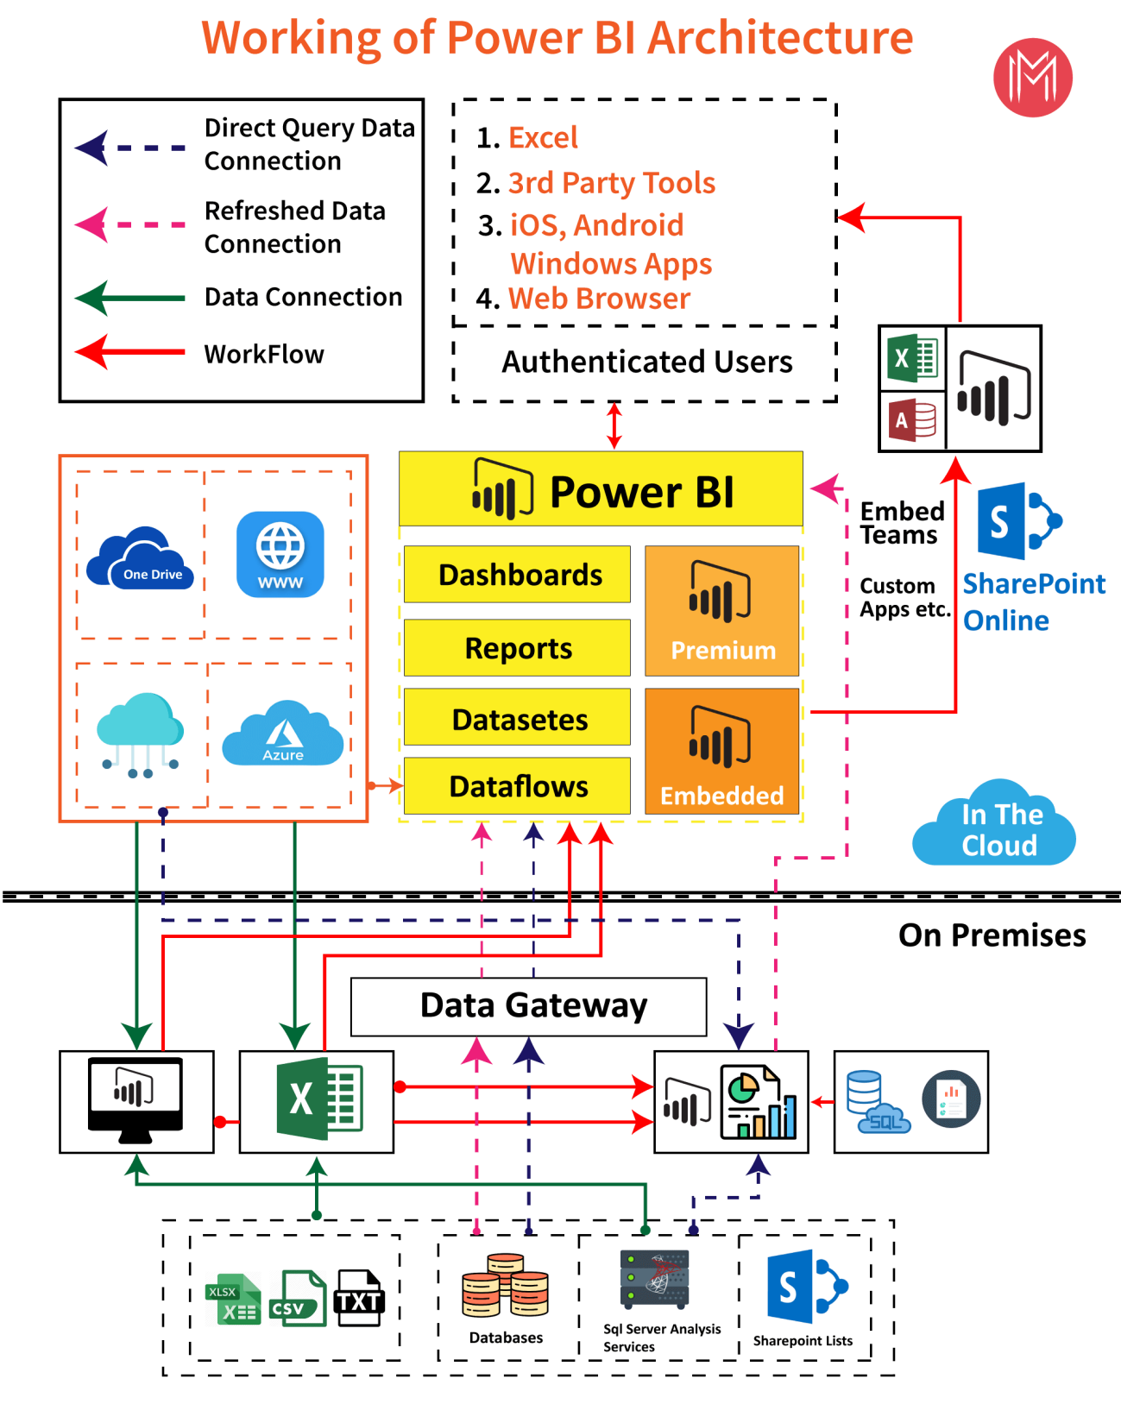

**Benefits :**

* + Integrates seamlessly with existing applications
  + Rich personalized dashboards
  + Publish reports securely
  + No memory and speed constraints
  + No specialized technical support required.
  + Extracting business intelligence rapidly and accurately.
  + Balanced simplicity and performance
  + Supports Advanced Data services
  + Uses natural language intuitive data exploration.

**REPORT CREATED WITH DESCRIPTION WITH POWER BI ON THE DATASET OF HOW COVID 19 IMPACTS ON WOMEN IN INDIA:**

* + Integrated with familiar Microsoft products.

**Important KPI on which reports are made:**

1. Total % of death and total cases by location worldwide in 2020.
2. %of pregnant women –month wise and state wise in 2020 in India 3. Total % of girls education rates in India –state wise in the year 2020.
3. % of Women entrepreneurs in 2020 month wise in India.
4. % of health women worker in India month wise and state wise-2020.
5. % of women mental health data during covid-19 in India month and state wise(top twelve).

**Visual Representation of the above KPIs are**

**given below with description:**

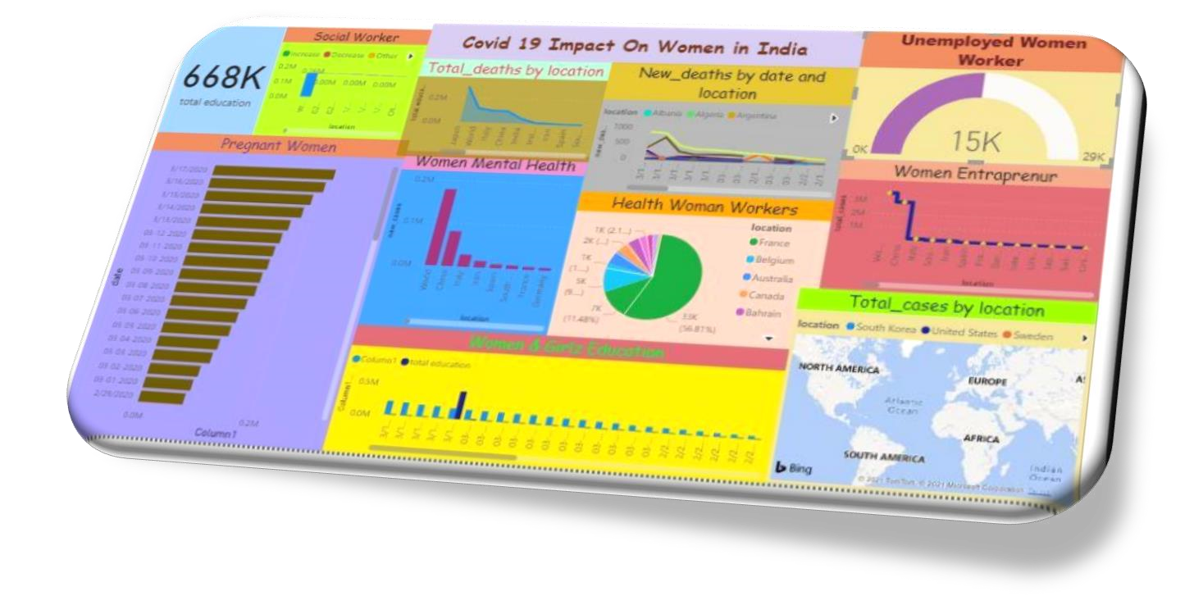

**Dash board created with power-Bi on the dataset of covid-19 impacts on indian women:**

**This is a power BI dashboard**, containing a single page ,it is also known as canvas, we are using this canvas to present our project most important elements. This dashboard is as an entryway into the underlying reports and datasets. Selecting a visualization takes you to the report that was used to create it.

# Death and total cases by location worldwide in 2020

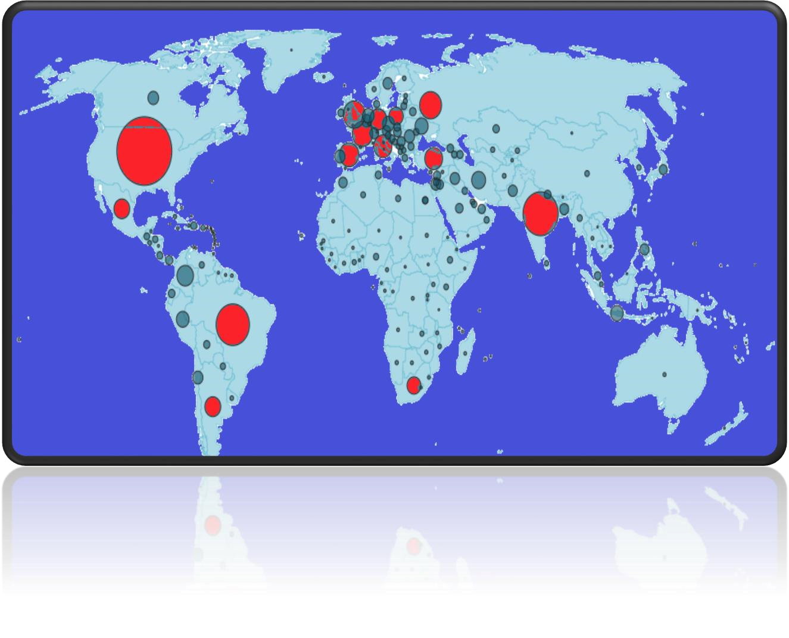

**As per the map** The US, India and Brazil have seen the highest number of confirmed cases, followed by the UK, Russia and a number of European countries.. **107,826,873**cases**2,369,734** deaths.(red circle are represent the highly effected area.)

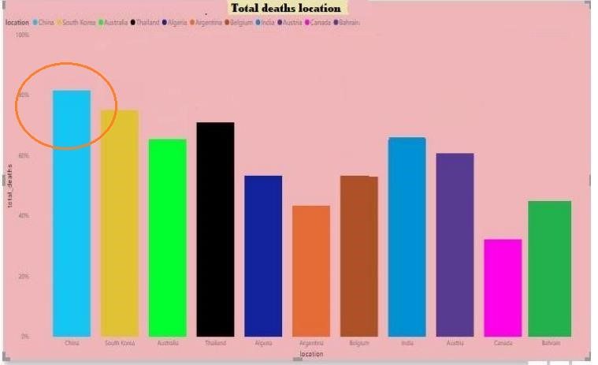

**According to this graph** different color of column representing different countries .with the graph we can see that china is highly affected by the corona virus. However INDIA also not in good position. As per the data set and the graph india,s total confirmed cases 10,880,603 and total death is155, 447 and death rate is

11.5(100,000 people).

**Effect on pregnant women –month wise and state wise in 2020 in india**

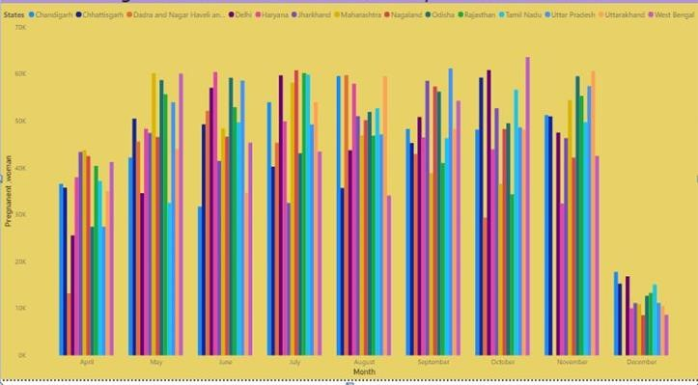

**According to the graph**  gradually pregnant women numbers has increased from april to December 2020 in corona period . in the month of October west Bengal pregnant women rate was very high it was around 63,658 and in the month of December 2020 Nagaland holding the lowest number of pregnant women around 8563.

**How girls and women education is affected in india –state wise in the year 2020.**

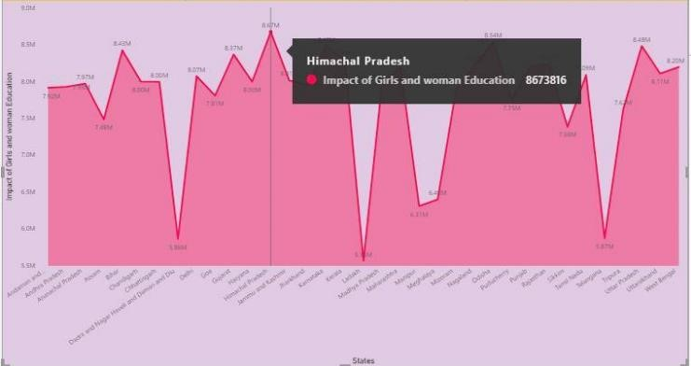

**This Area chart** shows information about girls and womens education status in the year 2020 state wise in India . As per the data women literacy rate was high in

Himachal Pradesh around 8.67 % in Ladakh around 5.56

%,Delhi-8.04,Goa-7.81%, west Bengal-8.20, Maharastra-

8.19,Kerla-8.29, Bihar-8.43.

**Impact on Women entrepreneurs in 2020 state wise in india.**

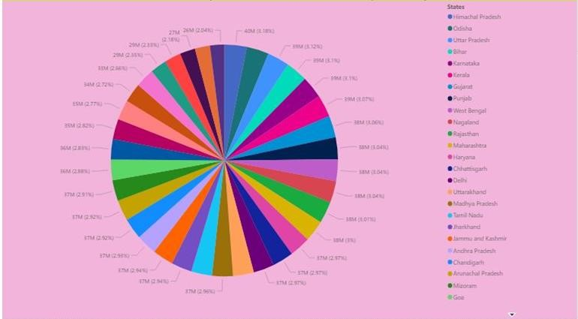

**This pie chart we have** created by using power bI and through this chart in the year of 2020 how much corona impacts on women entrapreneurs in india . Asper the graph Himachal pradesh’s women entrepreneurs around

3.18% where as Odisha 3.15%, ladakh standing with 2.04% , Telengana with

2.18%.,Chandigarh with 2.92%,Delhi-2.97%, Mdhyapradesh-2.96%West

Bengal-3.04%,Assam-2.77% ,Tamilnadu-2.96%, Rajasthan-

3.01%,Chattisgadh-2.97,Meghalaya-2.35, Bihar -3.10.

**Scenario of health women worker in india month wise and state wise-2020.**

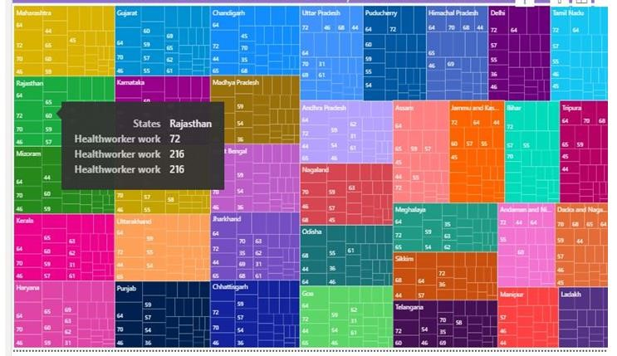

**As per this treemap** it is beautifully shows about the status of the health women worker in india in 2020 state wise , asper the graph and data kerala,s highest working women 251(per 1000 people) and lowest is 65 and Rajasthan Highest number of working women is 216(1,000 people) and lowest is 72,

Maharastra highest 256 and lowest 45,Delhi 216 and lowest 36,west

Bengal 144 and lowest 36

**How was women mental health status on covid-19 in india month and state wise(top twelve).**

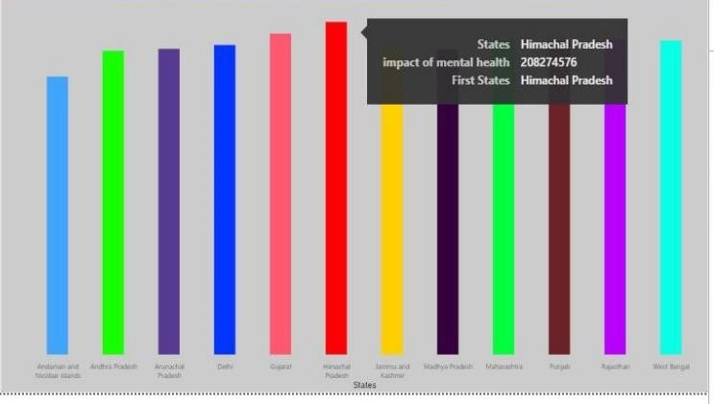

**Above column chart,** top twelve states are shown in india in the year 2020,different colored column representing each state ,according to this graph Himachal Pradesh standing with the highest position with 208M,Gujrat-200M, maharstra -

196M,Delhi-195M,Punjab-194M,Rajsthan-193m,West Bengal191,Andrapradesh-190,Arunachal Pradesh-192,Andaman Nicober -175.

**AIMS AND OBJECTIVES OF THE PROJECT:**

Our objective of the completion of this Project on “How does corona impact on Women in india during Covid-19” because Microsoft Power BI (business intelligence) is a powerful analytics tool that helps companies of all sizes analyze data and share insights. With this technology, enterprises can monitor their business more closely and get instant answers with rich dashboards available for every device. And it is necessary to practice and create effective visualization. it is to collect data about the organization from various data sources on corona virus ,pregnant woman, women entrepreneurs, etc and connect them to Power BI Desktop to create some rich reports and after that create dashboards. . The purpose of the project is to create and share real time insights of the dataset . so that decision maker will find it easy to understand the status of the situation on the basis of time. Real time Dash boards help management to take accurate decision as and when required. Management / Administration also plan for future initiatives on the present trends.

**CHALLENGES:**

The challenge of this project is that our team members worked very hard to collect data from different sources for completion of the project, we have used Power BI free version so many option were enabled. Some time we have faced so many technical issue with our devices,but our team members are very supportive and hardworking so we have successful to overcome the problematic situation effectively.our team spirit is the fuel that allows us to accomplish our project.

# CONCLUSION

Power BI is an excellent and robust business intelligence tool, and it is going to stay in the world of data visualization for a really long time. It helps hundreds of data sources to connect quickly, infusing life in the data through comprehensive reports.

so if we hold expertise in the field, that will be beneficial for our carrier. The ever-growing set of tools that Power BI contain holds the potential to provide with real, compelling and actionable insights from data, via dashboard-style reports. Power BI has various benefits that can help we and our organisation improve on our business intelligence. With this, After completion of this project now we have a clear picture of various working ways of Power BI, which will help you execute the same.